Transcriptional Response of Capsicum annuum L. Under Salinity Stress.
Nahla Salem Salama ² , Hagar Elhefnawi ¹, Mohamed Abdel-Salam Rashed¹, S.H. Abdel-Aziz ², ^{Mahmoud Magdy1}
1Department of Genetics, Faculty of Agriculture, Ain Shams University, Cairo, Egypt.
2Department of Botany and Microbiology, Faculty of Science, Benha University, Cairo, Egypt.

Abstract
Transcriptomic changes in plants during salinity stress give insights into the mechanisms with which plants stabilize their metabolic processes in order to cope with the salinity condition. Soil salinity is a major abiotic stress that limits plant growth and agricultural productivity. As pepper is a salt-sensitive vegetable crop, maintaining high K+/Na+ ratios in the tissues is important in achieving salt tolerance. We compared the transcriptomes of C.annuum under salt stress vs. control to identify candidate genes and pathways involved in salt response. Total of 70,845 genes were map by the RNA sequencing data. In which 49,077 were found to be exhibit non-significant differential expression in the roots. 4,621 genes were up regulated; 8,821genes were down regulated, while the retained genes (8,327) were found natural. The majority of the proteins have functions related to Functional and Metabolism Proteins (mitochondrial import receptor subunit TOM5 homolog (TOM5) and E3 ubiquitin-protein ligase PUB23-like (E3PUBL), Oxidative Stress Response/ROS Signaling((PCO1, pmsrB5, pd2, and NHLp6), Hormone signaling and transport(PINL3 isoform 1,2), ENOD93), Cell Wall and Cytoskeleton Metabolism((Glycine-rich proteins (GRPs) and Pectinesterase (pest)), in addition to stress and defense((Protein SAR DEFICIENT 4 (SARD-4) and acanthoscurrin-2). qRT-PCR was used to study the gene expression levels of the above-mentioned proteins. The comparative protein profiles of roots and leaves under salinity vs control improves the understanding of the molecular mechanisms involved in the tolerance of plants to salt stress. This work provides a good basis for further functional elucidation of these DEGs using genetic approaches as well as candidate genes for genetic engineering to improve crop salt tolerance.
Keywords: Capsicum annuum, differentially expressed genes, salt stress, RNA sequencing.

1. Introduction
Pepper (Capsicum annuum L.) is an economically important vegetable and spice plant of the Solanaceae family, is a rich source of vitamins, nutrients, and capsaicin, and is widely cultivated throughout the world (Lee et al., 2004; Moscone et al., 2007). In addition to promoting the growth of pepper, supplementary potassium can enhance the dry matter and chlorophyll concentrations under high salt treatments (Wamser et al., 2017; Kaya et al., 2020). As pepper is a salt-sensitive vegetable crop, maintaining high K⁺/Na⁺ ratios in the tissues is important in achieving salt tolerance. Salinity is a major constraint that poisons plant cells due to free radicals formation. To cope with the stress, plants developed several mechanisms including morphological and structural changes and increasing the secondary products (Céccoli et al., 2011). Salt stress affects plant cell metabolism and the production of carbohydrates, proteins (Mohamed and Ismail, 2011; Šutković et al., 2011), and enzymes (Gao et al., 2008) have been investigated in vitro in some plants.
Salinity limits plant growth through the negative effect of osmotic potential (Steiner et al., 2019; Pradi-Vendruscolo and Seleguini, 2020). The increase in salt concentration in the root zone makes water less available to plants (Shihab and Hamza, 2020). This leads to changes in water relations in plant cells (García-Caparrós and Lao, 2018) and the accumulation of ions (predominantly Na+ and/or Cl-) at toxic levels (Hossain et al., 2015, and Rady et al., 2018), which results in nutritional problems (Ceccarini et al., 2019; Shahzad et al., 2019; and Talhouni et al., 2019).
A few transcriptomic analyses have been carried out on Capsicum species to clarify the molecular mechanisms related to abiotic stress resistance. The RNA-seq analyses of pepper C. annuum treated with heat, cold, salinity, and osmotic stresses have provided valuable information to understand the abiotic responses of the Capsicum genus (Kang et al., 2020). Hwang et al. (2005) have characterized the changes occurring in the expression of cold-regulated differentially expressed genes (DEGs) in hot pepper C. annuum, and several genes appeared to be induced not only by cold stress but simultaneously by salinity. Most of the previous studies focused on the transcriptome of individual plants in response to salt stress in the natural environment (Dong et al., 2021; Wang et al., 2018). However, the mechanisms of salt stress tolerance in plants involve the expression of gene clusters rather than the expression of individual genes (Gong et al., 2013; Wang et al., 2018).
The final objective of the present study is to shed light on the complex molecular mechanisms that underline the responses of C. annuum to salt stress and the identification of candidate genes associated with salt tolerance.
2. Materials and Methods
2.1. Plant material and Salinity tolerance experiment
The collected cultivated germplasm from different regions of Egypt affected by salt stress (e.g. North Sinai region). Plantation of the collected germplasm under salinity conditions using a standard salinity-treatment experiment.
The experiment was conducted under greenhouse conditions at the Faculty of Agriculture, Ain Shams University. Seeds of the Gedeon F1 pepper cultivar (Capsicum annum L.) were sterilized using 1% sodium hypochlorite for 30 minutes. After washing with sterile water, the seeds were planted in perlite beds at a temperature of 28$℃$. Once germinated, the seedlings were transferred to pots and grown under 16 hours of light at 25$℃$ and 8 hours of darkness at 18$℃$, maintaining a relative humidity of 60%, until the seedlings developed six leaves. For the control group, roots were harvested from the seedlings, with three biological replicates. In the salt stress experiment, 35-day-old plants were irrigated with Hoagland solution supplemented with 200 mM NaCl solution. Samples, consisting of three to four roots, were collected with three biological replicates at 24 and 48 hours after treatment. The samples were rapidly frozen using liquid nitrogen and stored at -80C until RNA extraction.
2.2. Plasmolysis experiment
Once collecting the fresh, cleaned leaves (control and treatment), free-hand sections of each leaf's petiole and blade were made using a razor blade. These sections were then examined using a LEICA light microscope model DM-500.
2.3. RNA extraction and cDNA synthesis
Total RNA (including DNAse treatment) was extracted from the roots and leaves of stressed and control plants. Use the EasyPure® Plant RNA Kit (TransGen Biotech, Beijing, China) according to the manufacturer's instructions. The experiment involved three independent biological replicates for each case. The quantity and quality of RNA extracts were assessed by electrophoresis on 2% agarose gels and the Quantus™ Fluorometer (Promega, Madison, WI, USA).
mRNA was converted to cDNA using EasyScript® First-Strand DNA Synthesis SuperMix Green qPCR (TransGen Biotech, Beijing, China). In triplicates, reactions were performed and contained 100 ng of cDNA, 0.5µl of each primer (10µm/µl), and10lµ SYBR Green Master Mix in a final volume of 20µl. The amplification PCR program was set as follows: 95 C for 5 min, followed by 40 cycles of 95 C for 15 s, 55 C for 20 s, and 72 C for 30 s. Melting curve analysis was performed by increasing the temperature from 55 to 95 C (0.5 C per 10 s).
4. RNA seq data analysis
According to the manufacturer's protocol, an Illumina TruSeq Library Preparation Kit (Illumina, San Diego, CA, USA) was used to prepare approximately 350 bp of paired-end libraries for DNA inserts. The libraries were sequenced in pair-end mode generating raw data of 150 bp on an Illumina Hiseq 4000 platform (Novogene, China), following the manufacturer’s recommendations. The raw data were pre-processed using Trimmomatic 0.39 software (Bolger et al., 2014), including removing adapter sequences, and other sequences introduced during sequencing, low-quality, and over-N-base reads. The quality of newly produced clean short reads was assessed using FASTQC v0.11.9 (Andrews, 2010) and MULTIQC software (Ewels et al., 2016).

2.5 Gene expression quantification and differentially expressed gene identification
The changes in the relative abundance of transcripts in salinity versus control conditions were quantified and normalized to the number of reads per kilobase of transcripts per million mapped reads (RPKM). The gene expression levels were then estimated using the Cuffdiff program from the Cufflinks suite. The statistical significance level of differential expression of each gene in the root tissues was determined by initially setting false discovery rate (FDR)-adjusted P-values at 0.05 (which are known as Q-values), using the Benjamini and Hochberg method (Benjamini and Hochberg, 1995). However, in order to reduce the likelihood of false positives, only DEGs with a Q-value < 0.01 were considered for further analysis.
2.6. Quantitative real-time PCR validation of RNA-Seq data
To verify the RNA-seq data was reliable, selected salt stress-resistance-related DEGs in pepper as candidate genes performed for qRT-PCR validation. And 19 of these candidates were then randomly selected for qRT-PCR including nine up regulated and 10 down regulated genes. The specific primers for selected DEGs were designed using the program Primer3 (http://bioinfo.ut.ee/primer3-0.4.0/primer3) using default settings. All the primers were listed in Table 1.
The relative fold difference was calculated in each experiment using the ^{ΔΔ}Ct method (Livak & Schmittgen, 2001). Beta-actions were selected as an internal control to normalize all data. Using Microsoft Excel, the expression-based histograms were demonstrated, and the differences between cases were tested for significance using a one-tail paired T-test.
Table1. Specific Primers for the up regulated and down regulated DEGs
Gene_ID | Name | Start | End | 5'-Sequence-3' | Length(bp) | Product Size | Tm (C)
XM_016685722.2 | 1F | 426 | 445 | TGCTACTGCCATTCCAGCTT | 20 | 103 | 60
XM_016685722.2 | 1R | 509 | 528 | GCCAGCAGCTGTAGAGACAA | 20 | 103 | 60
XM_016707840.2 | 2F | 280 | 299 | TCTGTTGTCTCCAGTCGCAC | 20 | 103 | 60
XM_016707840.2 | 2R | 363 | 382 | AACCTGAGCGTGCCAGAATT | 20 | 103 | 60
XM_016720254.2 | 3F | 536 | 555 | TCCACACCCTTTTGACCCAC | 20 | 108 | 60
XM_016720254.2 | 3R | 624 | 643 | GGCTTGTTTGATGGGCATGG | 20 | 108 | 60
XM_016726838.2 | 4F | 597 | 616 | GTTGTGCCACTCCCCTCTAC | 20 | 111 | 60
XM_016726838.2 | 4R | 688 | 707 | CATCTGGGTCTGGATTGCGA | 20 | 111 | 60
XM_016708109.2 | 5F | 382 | 401 | CCTCCTCCTCCAGACATCCA | 20 | 116 | 60
XM_016708109.2 | 5R | 478 | 497 | TCCTTGGTTCCAGGACTTGC | 20 | 116 | 60
XM_016712548.2 | 6F | 128 | 151 | GCAAAAGAGTTGACTGAGACTTCA | 24 | 123 | 60
XM_016712548.2 | 6R | 231 | 250 | GCAGTATCCTCCACCACCAG | 20 | 123 | 60
XM_016700506.2 | 7F | 1011 | 1030 | CAACGATTCAACCCGCGATC | 20 | 132 | 60
XM_016700506.2 | 7R | 1123 | 1142 | TCGCCATAACCATACGCTCC | 20 | 132 | 60
XM_016714923.2 | 8F | 1389 | 1408 | GTCTTGGCTTACTGGGTGCT | 20 | 138 | 60
XM_016714923.2 | 8R | 1507 | 1526 | TAAAAGTCAAGGGGCGGACC | 20 | 138 | 60
XM_047410733.1 | 9F | 1501 | 1520 | GTCTTGGCTTACTGGGTGCT | 20 | 138 | 60
XM_047410733.1 | 9R | 1619 | 1638 | TAAAAGTCAAGGGGCGGACC | 20 | 138 | 60
XM_016713638.2 | 10F | 233 | 252 | CTTTCCTTCCCCTCGTGGAC | 20 | 150 | 60
XM_016713638.2 | 10R | 363 | 382 | AGCAAAGAAGGCGTCCATCA | 20 | 150 | 60
XM_016724820.2 | 11F | 96 | 115 | ATCTCCTCAACTCAAGCCGC | 20 | 167 | 60
XM_016724820.2 | 11R | 243 | 262 | GCGGCCTTGATGAGAGGATT | 20 | 167 | 60
XM_047407045.1 | 12F | 1121 | 1140 | GACACACTCTACGCCCACAA | 20 | 167 | 60
XM_047407045.1 | 12R | 1268 | 1287 | GTCTTGCCTTGCGCTGTTAC | 20 | 167 | 60
XR_007055421.1 | 13F | 369 | 388 | CCATCGCCACCATCTGTCTT | 20 | 178 | 60
XR_007055421.1 | 13R | 527 | 546 | TCCCTGTTGGTTTTGCCTGT | 20 | 178 | 60
XM_047408884.1 | 14F | 275 | 294 | CGGATATCCTGGTGGTGGTG | 20 | 183 | 60
XM_047408884.1 | 14R | 438 | 457 | GGATATCCACCACGACCACC | 20 | 183 | 60
XM_016706325.2 | 15F | 236 | 255 | TGGTGCCACGTAACTCTTCC | 20 | 186 | 60
XM_016706325.2 | 15R | 402 | 421 | CTGCTGCAATGCCTAGGAGT | 20 | 186 | 60
XM_016689259.2 | 16F | 699 | 718 | CAGATCTCACCCCGAACCAC | 20 | 210 | 60
XM_016689259.2 | 16R | 889 | 908 | TGCTCTCATTGGCATGGACA | 20 | 210 | 60
XR_007044660.1 | 17F | 463 | 483 | TGCCTCCATGTGAGTTTAGGT | 21 | 213 | 59
XR_007044660.1 | 17R | 656 | 675 | ACGTACCGTACCCTGCATTT | 20 | 213 | 59
XM_016717790.2 | 18F | 232 | 251 | GGCGAGAATCCCGTCGTTAT | 20 | 230 | 60
XM_016717790.2 | 18R | 442 | 461 | TACATCGCCGGCATCTCATC | 20 | 230 | 60
XR_007047511.1 | 19F | 359 | 378 | GATGACGTGGCATTTTCGGG | 20 | 240 | 60
XR_007047511.1 | 19R | 579 | 598 | GCGGCAACATGTGTTTGTTC | 20 | 240 | 60

3. RESULTS and Discussion
3.1 Plasmolysis Experiment
When capsicum annum was treated with a concentrated saline solution (200mML NaCl) for 24 hours, the parenchyma cells in the salt-treated leaf petiole and blade showed a clear signs of plasmolysis. This can be observed by the appearance of a space between the plasma membrane and cell wall in addition, change in the shape and organization of the parenchyma cells; additionally, the appearance of small green clusters in some areas as shown by the arrows in Fig.1 (B and D). In contrast, the parenchyma cells in the control samples of both leaf blade and petiole Fig.1 (A and C) were appeared in a regular hexagonal shape, filled with cytoplasm normally, and there was no visible space between the plasma membrane and cell wall, indicating that no osmotic damage occurred in these cells. Recent studies in molecular biology have raised more interest in the phenomenon of plasmolysis, it's a biological phenomenon that occurs when a plant cell loses water, and its contents shrink away from the cell wall. This phenomenon is not just a shape change, but rather a defense mechanism that plants responding to various environmental stresses such as drought, salinity, and extreme temperatures (Munns, R. 2002; Hsiao, T. C. 1973). Microscopic examination of C. annuum leaf tissues revealed significant structural changes in response to salt stress treatment (200 mM NaCl) for 24h. Our analysis focused on parenchyma cells in both leaf petioles and blade sections. The high agreement between our observations and the current understanding of plasmolysis was found as a defense mechanism in plants under environmental stress. Similar membrane disturbances in potato leaf parenchyma cells treated with 200 mM NaCl were reported by (Gao et al., 2015), Also, rice seedlings exposed to (400 mM NaCl) albeit at a higher concentration than our study showed similar plasmolysis symptoms (Pareek et al., 1997).
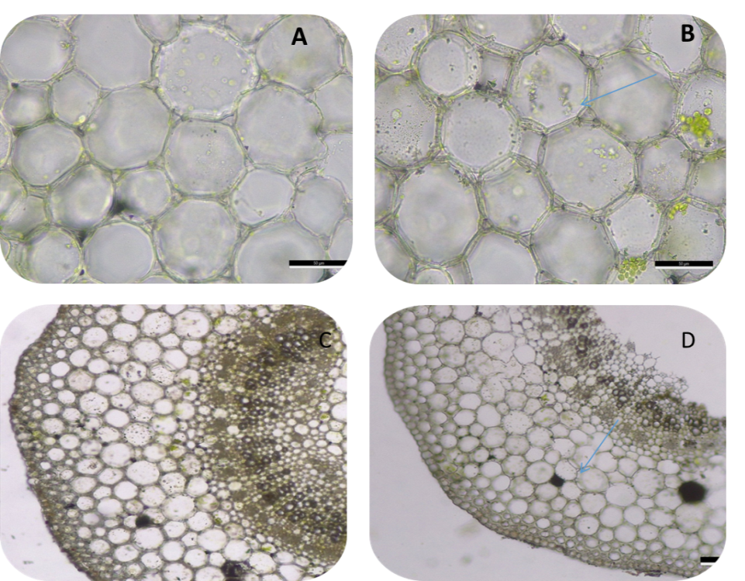
Figure (1) Anatomical changes in leaf petiole and leaf blade of Capsicum annum after treatment with 200mML of NaCl for 24 hours where (A) control leaf petiole, (B) treated leaf petiole, (C) control leaf blade, and (D) treated leaf blade.

3.2. RNA seq analysis
3.2.1. Identification of differentially expressed genes in roots under salt stress
To explore the transcriptional response to salt stress, genes in roots were tested for differential expression between the control and salt conditions. Expression levels for each gene were calculated and normalized to RPKM values. Initially, the multiple testing corrections involved a Q-value < 0.0001, and Total of 70,845 genes was map by the RNA sequencing data. In which 49,077 were found to be exhibit non-significant differential expression in the roots. 4,621 genes were up regulated; 8,821genes were down regulated, while the retained genes (8,327) were found natural. Subsequently, more stringent B-value (˂0.0001)were applied and log 2 ratio ˃4.8 to identify the most up regulated DEGs. Similarly, the stringent B-value (˂0.0001) and log 2 ratio ˃ - 6 were applied to identify the most down regulated DEGs. Resulting in a ten differentially expressed genes in each direction, among these sequences 3(15.7) were non -coding RNA or uncharacterized proteins. The distribution of these genes is provided in (Fig 2). As illustrated, in salt stress conditions, the number of down regulated genes was slightly higher than the number of up regulated genes.

Figure (2): Volcano plots of transcriptomes for salt-treated root tissues in Capsicum annuum (200Mml NaCl for 24h).All genes (Up and Down regulated) are represented in blue columns, except uncharacterized genes are represented in purple columns, and uncharacterized and noncoding genes are represented in red columns.
3.3. Candidate DEGs involved in response to salt stress
Based on function annotation, DEGs were allocated into several biological processes, involved in ion homeostasis, immune response, ROS scavenging, Amino acid metabolism, ABA signaling pathway, cell wall modification, redox regulation, repair, and import proteins. Table 2 highlights the most significant DEGs based on functional categories that were candidate salt-responsive genes.
In this study, 19 DEGs were selected in RNA-seq data of C. annuum roots under salt stress (Fig. 2).
3.3.1. Up-regulated differentially expressed genes (DEGs)
In response to salt stress, the roots of C. annuum exhibited significant changes in gene expression patterns. Nine genes showed up regulation, which can be categorized into two groups based on their expression levels (Fig. 2).
3.3.1.1. Highly Up-regulated DEGs (Log2 Ratio ≥5)
Included four genes: Early nodulin 93 (ENOD93), involved in transporting nutrients, amino acids, hormones, and solutes. ; Plant cysteine oxidase 1 (PCO1), which participates in oxidative stress responses and regulation of programmed cell death.; E3 ubiquitin-protein ligase PUB23-like (E3PUBL), which activates plant immune response to the salinity stress, and an uncharacterized gene LOC107867411 (Table 2&Fig. 2).
3.3.1.2. Minimally Up-regulated DEGs (Log2 Ratio ≤ 5)
Included five genes: mitochondrial import receptor subunit (TOM5) homolog, responsible for protein import into mitochondria; two isoforms of protein (PIN-LIKES 3) Isoform 1 and 2, involved in auxin transport; Acanthoscurrin-2 (aca-2), which has antimicrobial properties; and another uncharacterized gene LOC124898707(Table 2& Fig. 2).
3.3.2. Down-regulated differentially expressed genes (DEGs)
In response to the salt stress of the roots, the down-regulated DEGs showed ten genes, which were classified into two groups based on their expression levels (Fig. 2).
3.3.2.1. Highly Down-regulated DEGs (Log2 Ratio ≤ -5)
Include five significantly down-regulated genes: Glycine-rich protein (GRP) involved in cell wall structure; auxin-binding protein (ABP19a), which participates in auxin signaling, Pectinesterase (pest), which pectin metabolism, peptide methionine sulfoxide reductase B5 (PmsrB5), which regulate potassium/sodium homeostasis ,maintaining the activities and stability of ROS scavenging enzymes, hence protecting/ rescuing the proteins from oxidative damage., and an uncharacterized gene LOC124888726 (Table 2& Fig. 2).
3.3.2.2. Minimally down-regulated DEGs (Log2 Ratio ≥-5)
Include five slightly down-regulated genes: NDR1/HIN1-like protein 6 (NHLp6), which ABA signaling, glutaredoxin-C6 (Gc6), which maintenance of cellular redox homeostasis, proline dehydrogenase 2 mitochondrial-like(Pd2), which also in redox homeostasis, an osmotic adjustment under salt stress, protein SAR DEFICIENT 4 (SARD4), which involved in systemic acquired resistance, and an uncharacterized gene LOC124887267 (Table 2& Fig. 2).
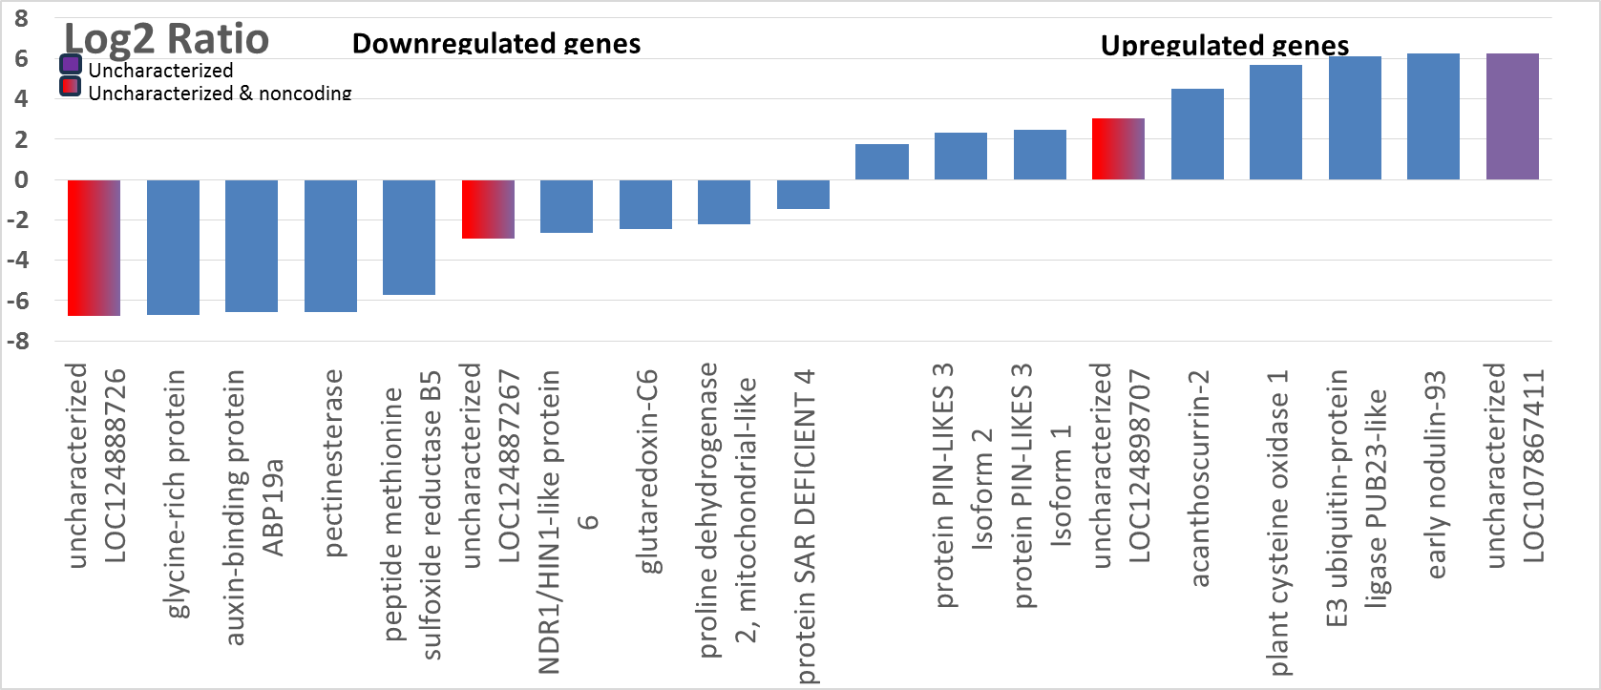

Figure (2): Volcano plots of transcriptomes for salt-treated root tissues in Capsicum annuum (200Mml NaCl for 24h).All genes (Up and Down regulated) are represented in blue columns, except uncharacterized genes are represented in purple columns, and uncharacterized and noncoding genes are represented in red columns.

Table 2: Nineteen DEGs were selected in RNA-seq data of C. annuum roots under salt stress.
Transcript_ID | GeneID_NCBI | RNA_Type | Length(bp) | GC% | Mw | Log2 Ratio | p-value | Regulation
XR_007047511.1 | LOC124888726 | ncRNA | 1120 | 35.50% | 358.3238158 | -6.757200542 | 0.0000000000025836 | Down
XM_016712548.2 | LOC107866513 | mRNA | 488 | 34.40% | 156.7674914 | -6.718105723 | 0.0000000000003788 | Down
XM_016724820.2 | LOC107877989 | mRNA | 928 | 42.60% | 296.1389668 | -6.595443432 | 0.0000000000004186 | Down
XM_047407045.1 | LOC107859557 | mRNA | 1819 | 40.20% | 584.5833256 | -6.559358517 | 0.0000000000029143 | Down
XM_016726838.2 | LOC107879910 | mRNA | 1147 | 38.00% | 367.6023532 | -5.723190721 | 0.0000000000013360 | Down
XR_007044660.1 | LOC124887267 | ncRNA | 850 | 30.20% | 272.253742 | -2.938445714 | 0.0000000000000028 | Down
XM_016706325.2 | LOC107860843 | mRNA | 1158 | 36.00% | 370.8165872 | -2.664039836 | 0.0000000000000000 | Down
XM_016717790.2 | LOC107871022 | mRNA | 650 | 44.30% | 208.8813134 | -2.436778945 | 0.0000000000000017 | Down
XM_016700506.2 | LOC107855488 | mRNA | 1928 | 40.10% | 620.0007326 | -2.229773961 | 0.0000000000000000 | Down
XM_016720254.2 | LOC107873409 | mRNA | 1660 | 40.50% | 532.380013 | -1.455062105 | 0.0000000000000002 | Down
XM_016707840.2 | LOC107862311 | mRNA | 771 | 38.80% | 246.9765136 | 1.772212373 | 0.0000000000000904 | Up
XM_016714923.2 | LOC107868272 | mRNA | 1675 | 42.00% | 537.4031362 | 2.332587964 | 0.0000000000000000 | Up
XM_047410733.1 | LOC107868272 | mRNA | 1787 | 41.00% | 573.5199618 | 2.451010254 | 0.0000000000000000 | Up
XR_007055421.1 | LOC124898707 | ncRNA | 734 | 41.10% | 235.763196 | 3.019764349 | 0.0000000000000169 | Up
XM_047408884.1 | LOC107864360 | mRNA | 784 | 51.40% | 254.1041152 | 4.492395976 | 0.0000000000000011 | Up
XM_016708109.2 | LOC107862505 | mRNA | 1528 | 38.00% | 490.5340542 | 5.672569677 | 0.0000000000139928 | Up
XM_016689259.2 | LOC107844938 | mRNA | 1993 | 36.50% | 637.8870118 | 6.109372243 | 0.0000000000085819 | Up
XM_016685722.2 | LOC107841880 | mRNA | 799 | 34.20% | 255.547337 | 6.225087565 | 0.0000000000001382 | Up
XM_016713638.2 | LOC107867411 | mRNA | 1413 | 44.50% | 454.970659 | 6.240913018 | 0.0000000000000000 | Up

3.4. Validation of the RNA-Seq and gene expression analysis by real-time qRT-PCR.
To validate the RNA-seq results, RT-qPCR analysis was performed on 19 candidate genes in salt tolerance at different time points in both leaves and roots of C. annuum. The housekeeping gene β-actin was used to normalize the control condition. Similar gene expression trends (upregulation or downregulation) in RT-qPCR analysis as that of RNA-seq for most samples (Fig. 3). For roots, Plant cysteine oxidase 1 (PCO1), protein PIN-LIKES 3 PINL3 (isoform 1) all showed up regulation, with the highest expression at 48h. While acanthoscurrin-2 (aca-2) showed the highest expression at 24h. In addition, pectinesterase (pest) and peptide methionine sulfoxide reductase B5 (PmsrB5) showed down regulation, with the highest expression of pest after 24h and PmsrB5 after 48h. For leaves, four genes showed highest expression level at 48 and 24h, namely nodulin 93 (ENOD93), NDR1/HIN1-like protein 6 (NHLp6), glycine-rich protein (grp), and proline dehydrogenase 2 (pd2). Additionally, two uncharacterized genes (LOC 726,707) were also expressed at 48h. An increase in the expression of some other genes that participate in activating defense was observed and resistance and regulating the hormonal response, some other vital and physiological processes associated with tolerance to salinity stress in both roots and leaves at 24 and 48h, especially protein SAR DEFICIENT 4 (SARD4) whose expression increased significantly after 48h of salt stress.

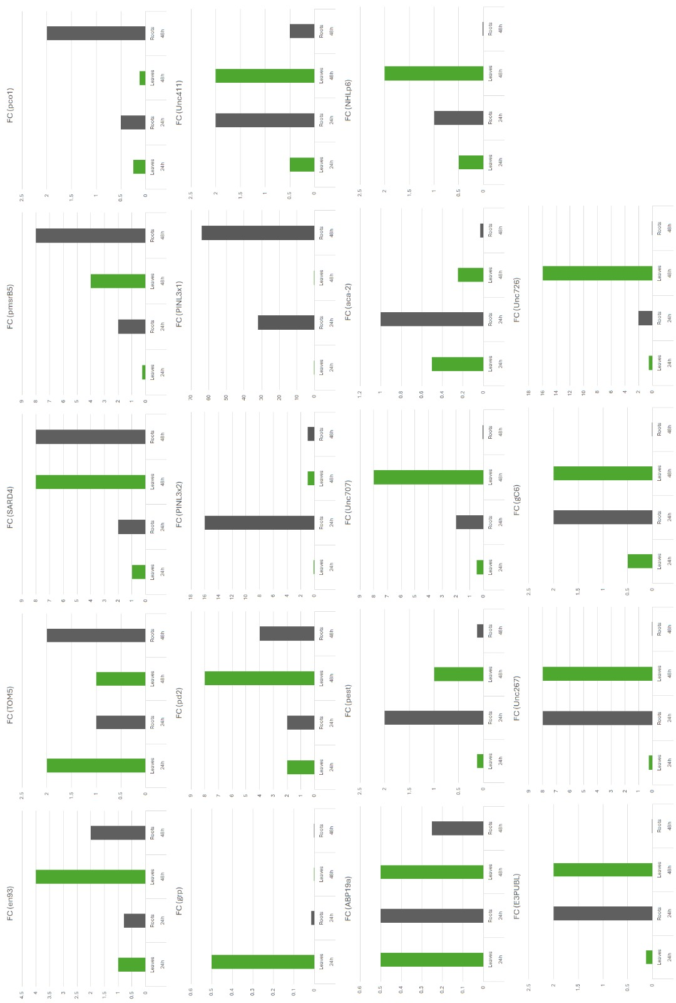

Fig.3. Selected expression profiles were validated with quantitative qRT-PCR in the roots (gray column) and leaves (green column) of C.annuum. X-axis, two-time points. While Y-axis, relative expression represented by mean fold changes of expression obtained from three biological replicates.

3.5. Generic Signaling Pathways Involved in C. annuum during Salinity Stress

The initiation of salinity stress triggered wide range responses, which implies that there are many genes and mechanisms involved in salt tolerance in C.annuum. According to their associated proteins, DEGs were classified as signaling and regulatory or functional.
Functional and Metabolism Proteins
Protein turnover represents a critical cellular regulatory mechanism that maintains a dynamic equilibrium between protein synthesis and degradation, enabling coordinated cellular responses (Reinbothe et al., 2010). Our investigation revealed enhanced expression of mitochondrial import receptor subunit TOM5 homolog (TOM5) and E3 ubiquitin-protein ligase PUB23-like (E3PUBL) in both leaves and roots. TOM5 arises as a crucial component of mitochondrial protein import machinery, facilitating precise and efficient protein translocation into mitochondria during stress conditions (Dietmeier et al., 1997). Complementing this, (Lister et al., 2004) observed significant transcript level increases in import components, particularly minor isoforms, when Arabidopsis cell cultures were exposed to mitochondrial electron transport chain inhibitors like rotenone and antimycin A, suggesting an adaptive compensatory mechanism to preserve mitochondrial functionality under stress. Regarding E3PUBL, its functional significance extends beyond conventional protein degradation. In plant immune systems, specifically in Arabidopsis, ubiquitin-protein ligases like AtPUB12 and AtPUB13 regulate receptor complex turnover by modulating the AtCERK1/AtLYK5 chitin receptor complex (Liao et al., 2017; Yamaguchi et al., 2017). This mechanism indicates that E3PUBL plays a nuanced role in activating plant immune responses, particularly in mitigating salinity stress through strategic protein modification and turnover.
Oxidative Stress Response/ROS Signaling
The generation of excess reactive oxygen species (ROS) during salt stress leads to oxidation of cellular components, resulting in irreversible damage to plant cells (Sekmen et al., 2014). ROS are primarily generated in plant cells in organelles characterized by high oxidizing metabolic activity or intense electron flow, such as chloroplasts, mitochondria, and microbodies. Among these, chloroplasts and peroxisomes are the primary contributors to oxidative load during abiotic stress conditions (Mittler et al., 2004). Analysis revealed that oxidative stress-responsive genes (PCO1, pmsrB5, pd2, and NHLp6) exhibited delayed expression patterns, showing responses after 48h in both root and leaf tissues under salt stress conditions. Research has shown that coordinated activation of these enzymatic systems is essential for maintaining cellular redox homeostasis and enhanced plant stress resistance mechanisms (Li et al., 2012; Al-Saadi and Kubba, 2015; Rey and Tarrago, 2018). Similar patterns were documented in various plant species, including Arabidopsis (Cai et al., 2023; Mittler et al., 2004) and wheat (Al-Saadi et al., 2024).
Hormone signaling and transport
Plant hormones are a group of small signaling molecules produced by plants at deficient concentrations that can move and function at distal sites. Hormone homeostasis is critical to balance plant growth and development and is regulated at multiple levels, including hormone biosynthesis, catabolism, perception, and transduction. In addition, plants move hormones over short and long distances to regulate various developmental processes and responses to environmental factors (Zhang et al., 2023). The auxin transporter proteins (PINL3 isoform 1,2) showed increased expression in roots, while the ABP19a were enhanced expressed in both roots and leaves, downregulated under salt conditions, which act as primary active auxin pumps that can transport against steep auxin gradients (Davies, 1995; Zhao et al., 2013; Geisler and Murphy, 2006). Similar findings were reported by (Luo et al., 2017) in sweet potato, and (Geisler et al., 2014; Blilou et al., 2005) in Arabidopsis. Furthermore, ENOD93 was reported to be expressed in the leaves after treatment 48h, which involves the transport of nutrients, amino acids, hormones, and other major aspects of plant development (Denance et al., 2014). Also, Terada et al., (2001) reported that a high concentration of auxin might lead to the induction of ENOD93 expression through interaction between Nod factor signaling molecules and auxin signaling pathways.

Cell Wall and Cytoskeleton Metabolism

The cytoskeleton is rapidly remodeled to adjust cell size to maintain normal cell turgor pressure under salt stress conditions (Zhang et al., 2012). The change in cell wall metabolism and cell wall-modifying enzyme activity in controlling cell wall plasticity is an important physiological mechanism of plants in response to stress. The (GRPs) and (pest) play crucial roles in regulating cell wall modification and response to various stresses (Ortega-Amaro et al., 2015; Wu et al., 2017). Our research displayed that Glycine-rich proteins (GRPs) and Pectinesterase (pest) had distinct expression profiles in both root and leaf, although they were significantly down regulated by salt stress, these results were similar to those (Czolpinska and Rurek, 2018; Kwak et al., 2005) who reported that the expression of GRPs can be induced by various stresses and change with different species, indicating that they play different roles in terms of stress resistance. In the same way, some reports have shown that the expression of the pest gene is affected by various stresses (Yan et al., 2018; Qu et al., 2011).

Stress and Defense

Plants suffer various types of inevitable exogenous stresses, such as pathogen attacks, insect herbivory, and abiotic environmental stress. To survive such unfavorable conditions, plants have evolved unique hormonally regulated self-protection systems (Yasuda et al., 2008), such as Protein SAR DEFICIENT 4 (SARD-4) and acanthoscurrin-2 (aca-2), which participate in the innate immune response (Lorenzini et al., 2003; Kumar et al., 2020). Our study showed a high expression of these proteins. Yasuda et al., (2008) revealed a mutual interaction between induction of SAR and environmental stress response signals activated by NaCl.
On the other hand, this de novo RNA sequencing assembly approach allowed to explore so-called orphan genes, taxonomically distinct genes that lack a distinguishable homology to unrelated species, salt tolerance (Khalturin et al., 2009). Orphan genes often contribute novel, lineage-specific functionality under extreme abiotic and biotic stresses (Donoghue et al., 2011). In the present study, there were 49,077 putative genes identified in C. annuum that have no matches to the NCBI sequence database. Of these unknown sequences, two were upregulated and two were down regulated. Although it is difficult to discern if these sequences encode functional proteins without further investigation, the high levels of expression following salt stress suggest that these orphan genes may play important roles in conferring salt tolerance (Dong et al., 2015). This highlights the potential to discover novel species-specific genes and pathways in beach morning glory.

References
- Al–Saadi, W. K., & Kubba, A. J. (2015). Jestimation of efficient of random primers and effect of salt stress on chlorophyll b content in some bread wheat cultivars. Iraqi Journal of Agricultural Sciences, 46(4), 644-651
- Al-Saadi, W. K., Hamdalla, M. S., & Aljuaifari, W. (2024). Morphological, Biochemical and Proline-Related Genes Analyses in Resistant and Susceptible Wheat Cultivars in Iraq. Basrah Journal of Agricultural Sciences, 37(1), 119-133.‏
- Andrews, S. (2010). FastQC A Quality Control tool for High Throughput Sequence Data [Online][WWW Document]. URL http://www. bioinformatics. babraham. ac. uk/projects/fastqc/(accessed 11.19. 20).‏
- Benjamini, Y., & Hochberg, Y. (1995). Controlling the false discovery rate: a practical and powerful approach to multiple testing. Journal of the Royal statistical society: series B (Methodological), 57(1), 289-300.‏
- Blilou, I., Xu, J., Wildwater, M., Willemsen, V., Paponov, I., Friml, J., ... & Scheres, B. (2005). The PIN auxin efflux facilitator network controls growth and patterning in Arabidopsis roots. Nature, 433(7021), 39-44.
- Bolger, A. M., Lohse, M., & Usadel, B. (2014). Trimmomatic: a flexible trimmer for Illumina sequence data. Bioinformatics, 30(15), 2114-2120.‏
- Cai, Y. S., Cai, J. L., Lee, J. T., Li, Y. M., Balladona, F. K., Sukma, D., & Chan, M. T. (2023). Arabidopsis AtMSRB5 functions as a salt-stress protector for both Arabidopsis and rice. Frontiers in Plant Science, 14, 1072173.‏
- Ceccarini, C., Antognoni, F., Biondi, S., Fraternale, A., Verardo, G., Gorassini, A., & Scoccianti, V. (2019). Polyphenol-enriched spelt husk extracts improve growth and stress-related biochemical parameters under moderate salt stress in maize plants. Plant physiology and biochemistry, 141, 95-104.
- Céccoli, G., Ramos, J. C., Ortega, L. I., Acosta, J. M., & Perreta, M. G. (2011). Salinity induced anatomical and morphological changes in Chloris gayana Kunth roots. Biocell, 35(1), 9-17.‏
- Czolpinska, M., & Rurek, M. (2018). Plant glycine-rich proteins in stress response: An emerging, still prospective story. Frontiers in plant science, 9, 302.‏‏‏ ‏‏ ‏ ‏‏
- Davies, P. J. (1995). The plant hormone concept: concentration, sensitivity and transport. In Plant hormones: physiology, biochemistry and molecular biology (pp. 13-38). Dordrecht: Springer Netherlands.‏
- Denancé, N., Szurek, B., & Noël, L. D. (2014). Emerging functions of nodulin-like proteins in non-nodulating plant species. Plant and cell physiology, 55(3), 469-474.
- Dietmeier, K., Hönlinger, A., Bömer, U., Dekker, P. J., Eckerskorn, C., Lottspeich, F., ... & Pfanner, N. (1997). Tom5 functionally links mitochondrial preprotein receptors to the general import pore. Nature, 388(6638), 195-200.
- Dong, S., Sang, L., Xie, H., Chai, M., & Wang, Z. Y. (2021). Comparative transcriptome analysis of salt stress-induced leaf senescence in Medicago truncatula. Frontiers in Plant Science, 12, 666660.
- Dong, X., Yi, H., Lee, J., Nou, I. S., Han, C. T., & Hur, Y. (2015). Global gene-expression analysis to identify differentially expressed genes critical for the heat stress response in Brassica rapa. PLoS One, 10(6), e0130451.‏
- Donoghue, M. T., Keshavaiah, C., Swamidatta, S. H., & Spillane, C. (2011). Evolutionary origins of Brassicaceae specific genes in Arabidopsis thaliana. BMC evolutionary biology, 11, 1-23.
- Ewels, P., Magnusson, M., Lundin, S., & Käller, M. (2016). MultiQC: summarize analysis results for multiple tools and samples in a single report. Bioinformatics, 32(19), 3047-3048.‏
- Gao, H. J., Yang, H. Y., Bai, J. P., Liang, X. Y., Lou, Y., Zhang, J. L., ... & Chen, Y. L. (2015). Ultrastructural and physiological responses of potato (Solanum tuberosum L.) plantlets to gradient saline stress. Frontiers in plant science, 5, 787.‏
- Gao, S., Ouyang, C., Wang, S., Xu, Y., Tang, L., & Chen, F. (2008). Effects of salt stress on growth, antioxidant enzyme and phenylalanine ammonia-lyase activities in Jatropha curcas L. seedlings. Plant Soil Environ, 54(9), 374-381.
- García-Caparrós, P., & Lao, M. T. (2018). The effects of salt stress on ornamental plants and integrative cultivation practices. Scientia horticulturae, 240, 430-439.
- Geisler, M., & Murphy, A. S. (2006). The ABC of auxin transport: the role of p-glycoproteins in plant development. FEBS letters, 580(4), 1094-1102.
- Geisler, M., Wang, B., & Zhu, J. (2014). Auxin transport during root gravitropism: transporters and techniques. Plant Biology, 16, 50-57.
- Gong, B., Wen, D., VandenLangenberg, K., Wei, M., Yang, F., Shi, Q., & Wang, X. (2013). Comparative effects of NaCl and NaHCO3 stress on photosynthetic parameters, nutrient metabolism, and the antioxidant system in tomato leaves. Scientia Horticulturae, 157, 1-12.
- Hossain, H., Rahman, M. A., Alam, M. S., & Singh, R. K. (2015). Mapping of quantitative trait loci associated with reproductive‐stage salt tolerance in rice. Journal of Agronomy and Crop Science, 201(1), 17-31.‏
- Hsiao, T. C. (1973). Plant responses to water stress. Annual review of plant physiology, 24(1), 519-570.‏
- Hwang, E. W., Kim, K. A., Park, S. C., Jeong, M. J., Byun, M. O., & Kwon, H. B. (2005). Expression profiles of hot pepper (Capsicum annuum) genes under cold stress conditions. Journal of Biosciences, 30, 657-667.
- Kang, W. H., Sim, Y. M., Koo, N., Nam, J. Y., Lee, J., Kim, N., & Yeom, S. I. (2020). Transcriptome profiling of abiotic responses to heat, cold, salt, and osmotic stress of Capsicum annuum L. Scientific Data, 7(1), 17.
- Kaya, C., Ashraf, M., Alyemeni, M. N., & Ahmad, P. (2020). The role of endogenous nitric oxide in salicylic acid-induced up-regulation of ascorbate-glutathione cycle involved in salinity tolerance of pepper (Capsicum annuum L.) plants. Plant Physiology and Biochemistry, 147, 10-20.‏
- Khalturin, K., Hemmrich, G., Fraune, S., Augustin, R., & Bosch, T. C. (2009). More than just orphans: are taxonomically-restricted genes important in evolution?. Trends in Genetics, 25(9), 404-413.
- Kumar, A., Singh, S., Gaurav, A. K., Srivastava, S., & Verma, J. P. (2020). Plant growth-promoting bacteria: biological tools for the mitigation of salinity stress in plants. Frontiers in microbiology, 11, 1216.
- Kwak, K. J., Kim, Y. O., & Kang, H. (2005). Characterization of transgenic Arabidopsis plants overexpressing GR-RBP4 under high salinity, dehydration, or cold stress. Journal of Experimental Botany, 56(421), 3007-3016.‏
- Lee, Y. H., Kim, H. S., Kim, J. Y., Jung, M., Park, Y. S., Lee, J. S., ... & Harn, C. H. (2004). A new selection method for pepper transformation: callus-mediated shoot formation. Plant cell reports, 23, 50-58.
- Li, C. W., Lee, S. H., Chieh, P. S., Lin, C. S., Wang, Y. C., & Chan, M. T. (2012). Arabidopsis root-abundant cytosolic methionine sulfoxide reductase B genes MsrB7 and MsrB8 are involved in tolerance to oxidative stress. Plant and Cell Physiology, 53(10), 1707-1719.
- Liao, D., Cao, Y., Sun, X., Espinoza, C., Nguyen, C. T., Liang, Y., & Stacey, G. (2017). Arabidopsis E3 ubiquitin ligase PLANT U‐BOX13 (PUB 13) regulates chitin receptor LYSIN MOTIF RECEPTOR KINASE5 (LYK 5) protein abundance. New Phytologist, 214(4), 1646-1656.
- Lister, R., Chew, O., Lee, M. N., Heazlewood, J. L., Clifton, R., Parker, K. L., ... & Whelan, J. (2004). A transcriptomic and proteomic characterization of the Arabidopsis mitochondrial protein import apparatus and its response to mitochondrial dysfunction. Plant physiology, 134(2), 777-789.
- Livak, K. J., & Schmittgen, T. D. (2001). Analysis of relative gene expression data using real-time quantitative PCR and the 2− ΔΔCT method. methods, 25(4), 402-408.‏
- Lorenzini, D. M., da Silva Jr, P. I., Fogaça, A. C., Bulet, P., & Daffre, S. (2003). Acanthoscurrin: a novel glycine-rich antimicrobial peptide constitutively expressed in the hemocytes of the spider Acanthoscurria gomesiana. Developmental & Comparative Immunology, 27(9), 781-791.
- Luo, Y., Reid, R., Freese, D., Li, C., Watkins, J., Shi, H., ... & Song, B. H. (2017). Salt tolerance response revealed by RNA-Seq in a diploid halophytic wild relative of sweet potato. Scientific Reports, 7(1), 9624.
- Mittler, R., Vanderauwera, S., Gollery, M., & Van Breusegem, F. (2004). Reactive oxygen gene network of plants. Trends in plant science, 9(10), 490-498.‏
- Mohamed, A. N., & Ismail, M. R. (2011). Changes in organic and inorganic solutes of'in vitro'tomato cultivars under NaCl stress. Australian Journal of Crop Science, 5(8), 939-944.
- Moscone, E. A., Scaldaferro, M. A., Grabiele, M., Cecchini, N. M., García, Y. S., Jarret, R., ... & Ehrendorfer, F. (2007). The evolution of chili peppers (Capsicum-Solanaceae): a cytogenetic perspective. Acta horticulturae, 745, 137.
- ‏Munns, R. (2002). Salinity, growth and phytohormones. In Salinity: environment-plants-molecules (pp. 271-290). Dordrecht: Springer Netherlands.‏
- Ortega-Amaro, M. A., Rodríguez-Hernández, A. A., Rodríguez-Kessler, M., Hernández-Lucero, E., Rosales-Mendoza, S., Ibáñez-Salazar, A., ... & Jiménez-Bremont, J. F. (2015). Overexpression of AtGRDP2, a novel glycine-rich domain protein, accelerates plant growth and improves stress tolerance. Frontiers in plant science, 5, 782.
- Pareek, A., Singla, S. L., Kush, A. K., & Grover, A. (1997). Distribution patterns of HSP 90 protein in rice. Plant Science, 125(2), 221-230.‏
- Pradi-Vendruscolo, E., & Seleguini, A. (2020). Effects of vitamin pre-sowing treatment on sweet maize seedlings irrigated with saline water. Acta Agronómica, 69(1), 20-25.‏
- Qu, T., Liu, R., Wang, W., An, L., Chen, T., Liu, G., & Zhao, Z. (2011). Brassinosteroids regulate pectin methylesterase activity and AtPME41 expression in Arabidopsis under chilling stress. Cryobiology, 63(2), 111-117.‏
- Rady, M. O., Semida, W. M., Abd El-Mageed, T. A., Hemida, K. A., & Rady, M. M. (2018). Up-regulation of antioxidative defense systems by glycine betaine foliar application in onion plants confer tolerance to salinity stress. Scientia Horticulturae, 240, 614-622.
- Reinbothe, C., Pollmann, S., & Reinbothe, S. (2010). Singlet oxygen signaling links photosynthesis to translation and plant growth. Trends in plant science, 15(9), 499-506.‏
- Rey, P., & Tarrago, L. (2018). Physiological roles of plant methionine sulfoxide reductases in redox homeostasis and signaling. Antioxidants, 7(9), 114.‏‏.‏
- Sekmen, A. H., Ozgur, R., Uzilday, B., & Turkan, I. (2014). Reactive oxygen species scavenging capacities of cotton (Gossypium hirsutum) cultivars under combined drought and heat induced oxidative stress. Environmental and Experimental Botany, 99, 141-149.‏
- Shahzad, M., Usman, H., Ahmad, R., Khan, S. A., Saqib, Z. A., & Mühling, K. H. (2019). Sodium in the leaf apoplast does not affect growth of maize (Zea mays L.) under saline field conditions. Journal of Applied Botany and Food Quality, 92, 117-122.
- Shihab, M. O., & Hamza, J. H. (2020). Seed priming of sorghum cultivars by gibberellic and salicylic acids to improve seedling growth under irrigation with saline water. Journal of Plant Nutrition, 43(13), 1951-1967.
- Steiner, F., Zuffo, A. M., Busch, A., Sousa, T. D. O., & Zoz, T. (2019). Does seed size affect the germination rate and seedling growth of peanut under salinity and water stress? Pesquisa Agropecuária Tropical, 49.
- Šutković, J., Ler, D., & Gawwad, M. R. A. (2011). Vitro production of Solasodine alkaloid in Solanum nigrum under salinity stress. Journal of Phytology, 3(1).‏
- Talhouni, M., Sönmez, K., Kiran, S., Beyaz, R., Yildiz, M., Kuşvuran, Ş., & Ellialtıoğlu, Ş. Ş. (2019). Comparison of salinity effects on grafted and non-grafted eggplants in terms of ion accumulation, MDA content, and antioxidative enzyme activities. Advances in Horticultural Science, 33(1), 87-96.
- Taylor‐Kearney, L. J., & Flashman, E. (2022). Targeting plant cysteine oxidase activity for improved submergence tolerance. The Plant Journal, 109(4), 779-788.
- Terada, R., Ignacimuthu, S., Bauer, P., Kondorosi, E., Schultze, M., Kondorosi, A., ... & Sautter, C. (2001). Expression of early nodulin promoter gene in transgenic rice. Current Science, 270-276.
- Wamser, A. F., Cecilio Filho, A. B., Nowaki, R. H. D., Mendoza-Cortez, J. W., & Urrestarazu, M. (2017). Influence of drainage and nutrient-solution nitrogen and potassium concentrations on the agronomic behavior of bell-pepper plants cultivated in a substrate. PloS one, 12(7), e0180529.‏
- Wang, L., Du, H., Li, T., & Wuyun, T. N. (2018). De novo transcriptome sequencing and identification of genes related to salt stress in Eucommia ulmoides Oliver. Trees, 32, 151-163.
- Wu, H. C., Huang, Y. C., Stracovsky, L., & Jinn, T. L. (2017). Pectin methylesterase is required for guard cell function in response to heat. Plant signaling & behavior, 12(6), e1338227.
- Yamaguchi, K., Mezaki, H., Fujiwara, M., Hara, Y., & Kawasaki, T. (2017). Arabidopsis ubiquitin ligase PUB12 interacts with and negatively regulates Chitin Elicitor Receptor Kinase 1 (CERK1). PLoS One, 12(11), e0188886.‏‏‏
- Yan, L., Riaz, M., Wu, X., Du, C., Liu, Y., & Jiang, C. (2018). Ameliorative effects of boron on aluminum induced variations of cell wall cellulose and pectin components in trifoliate orange (Poncirus trifoliate (L.) Raf.) rootstock. Environmental pollution, 240, 764-774.
- Yasuda, M., Ishikawa, A., Jikumaru, Y., Seki, M., Umezawa, T., Asami, T., ... & Nakashita, H. (2008). Antagonistic interaction between systemic acquired resistance and the abscisic acid–mediated abiotic stress response in Arabidopsis. The Plant Cell, 20(6), 1678-1692.
- Zhang, H., Han, B., Wang, T., Chen, S., Li, H., Zhang, Y., & Dai, S. (2012). Mechanisms of plant salt response: insights from proteomics. Journal of proteome research, 11(1), 49-67.
- Zhang, Y., Berman, A., & Shani, E. (2023). Plant hormone transport and localization: signaling molecules on the move. Annual review of plant biology, 74(1), 453-479.‏
- Zhao, Q., Zhang, H., Wang, T., Chen, S., & Dai, S. (2013). Proteomics-based investigation of salt-responsive mechanisms in plant roots. Journal of proteomics, 82, 230-253.

